[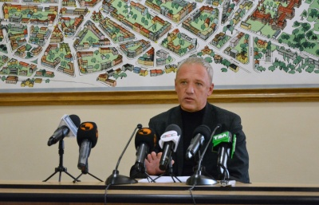](https://molbuk.ua/uploads/posts/2021-10/1633717122_244701718_894144744551947_3390772890808241810_n.jpg)